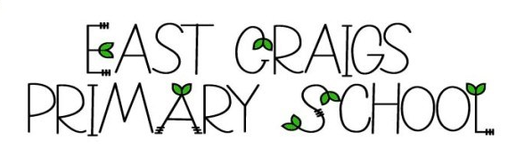
EAST CRAIGS PRIMARY SCHOOL
79 CRAIGMOUNT BRAE
EDINBURGH EH12 8XF
Telephone 0131-339 7115
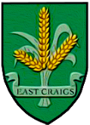
admin@eastcraigs.edin.sch.uk

Mrs Pamela Briggs
Headteacher

Welcome to East Craigs Primary School

Starting School
Starting school is an exciting time for both children and parents. We aim to make the transition from Early Learning and Childcare to school as smooth as possible and we have a variety of events planned over the coming weeks to support this. Through the activities we have planned, we hope that both parents and children will become more confident and relaxed about starting school.
We are looking forward to working together with you for the benefit and wellbeing of your child. If you feel your child requires any individual support during the transition to P1 or when starting school, please do get in touch.

Here are some of the activities we are planning in addition to our 'in-person' events:

- Every year, The City of Edinburgh Early Years Team support a transition project with all Early Learning and Childcare settings and schools across the city. The project is based on the well-known children’s book ‘The Everywhere Bear’ by Julia Donaldson.
- We will be sending out a video to the children all about East Craigs. This video will have photographs of different areas of the school with information about what happens in those places. It will also include photographs of the staff team.
- We will issue an information pack about starting school before the start of the summer holidays. This pack will contain information about preparing for school, what to expect in those the first few days and weeks and will include some dates and timings to help you to plan ahead.
- Finally, we will be in touch with your child's Early Learning and Childcare setting as part of the transition process and look forward to visiting your child in their setting. We will also be receiving a copy of their transition report in June. When we contact the settings, we will ask the staff to let you know the date of visit. If your child has moved to a new setting since you registered your child for Primary One, please email us.

Breakfast Club and Afterschool Club
Breakfast Club and After School Club provision is provided by KruKlub at East Craigs Primary School. Please see the flyer below for further information. Please contact Suzanne directly, if you'd like a place at Breakfast Club or After School Club.
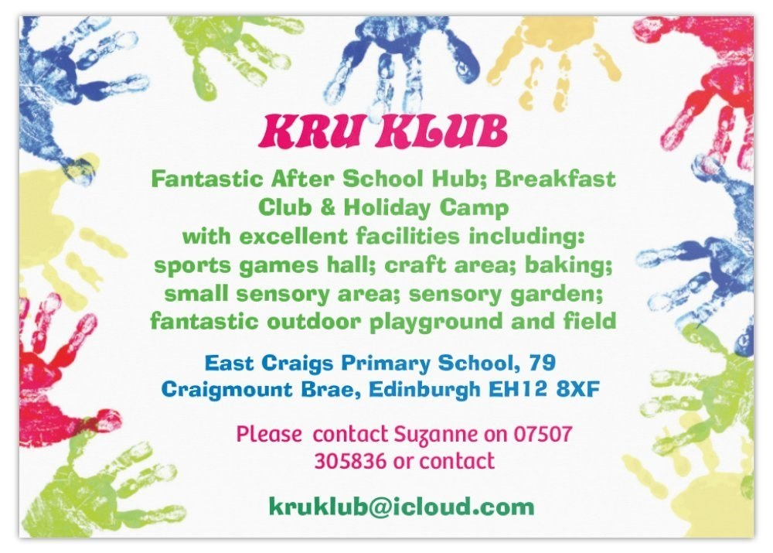

Free school meals and school clothing grants
All children in primary 1 to 5, at schools run by their local council or funded by the Scottish Government, can get free school lunches during term-time. Your financial circumstances do not matter.

Families on low income can apply for free school meals and clothing grants which includes: -
- payment for lunches during school holidays
- free milk or healthy snack
- a school clothing grant payment of £120 for each primary child and £150 for each secondary child, paid once a year into your bank account.
From 1 April, children and young people will be eligible to receive free school meals through targeted provision if their parents or carers are in receipt of any of the following:
Free school meals and school clothing grants
All children in primary 1 to 5, at schools run by their local council or funded by the Scottish Government, can get free school lunches during term-time. Your financial circumstances do not matter.

Families on low income can apply for free school meals and clothing grants which includes: -
- payment for lunches during school holidays
- free milk or healthy snack
- a school clothing grant payment of £120 for each primary child and £150 for each secondary child, paid once a year into your bank account.
From 1 April, children and young people will be eligible to receive free school meals through targeted provision if their parents or carers are in receipt of any of the following:
- Income support.
- Income-based Job Seeker’s Allowance.
- Income-based Employment and Support Allowance.
- Support under Part VI of the Immigration and Asylum Act 1999.
- Universal Credit (where their monthly earned income is not more than £796).
- Child Tax Credit, but not Working Tax Credit, where their income is less than £19,995
- Both Child Tax Credit and Working Tax Credit where their income is not more than £9,552.
The Regulations which seek to amend the eligibility criteria for recipients of both Child Tax Credit and Working Tax Credit, or Universal Credit, can be viewed through the following web link: The Education (Scotland) Act 1980 (Modification) Regulations 2024 (legislation.gov.uk)

For more information about FSM along with details on how to apply, please see the links below:
https://www.mygov.scot/primary-school-meals


https://www.edinburgh.gov.uk/food-clothing/free-school-meals-school-clothing-grants

Dates for your Diary
Please see attached flier detailing the dates and times of our events.
Please do not worry if you can't attend all the events we have planned. More information about each event will be sent out in due course.

Getting in Touch
If you have any questions or queries, please do not hesitate to get in touch.
admin@eastcraigs.edin.sch.uk

We look forward to seeing you soon.
Lisa Bradley
Depute Head Teacher

